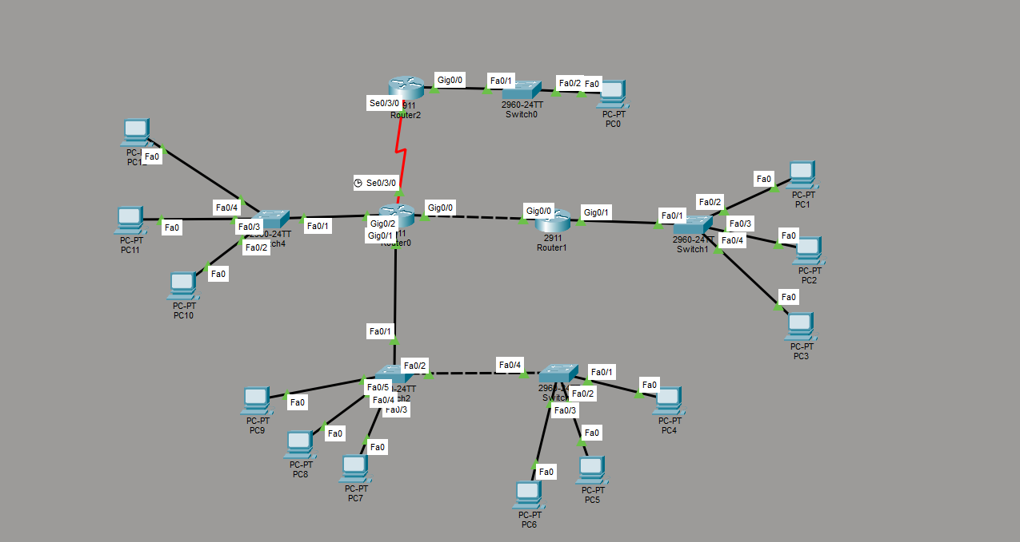
მოსამზადებელი ტოპოლოგია.

ამოცანის პირობა რის მიხედვითაც აიგო:
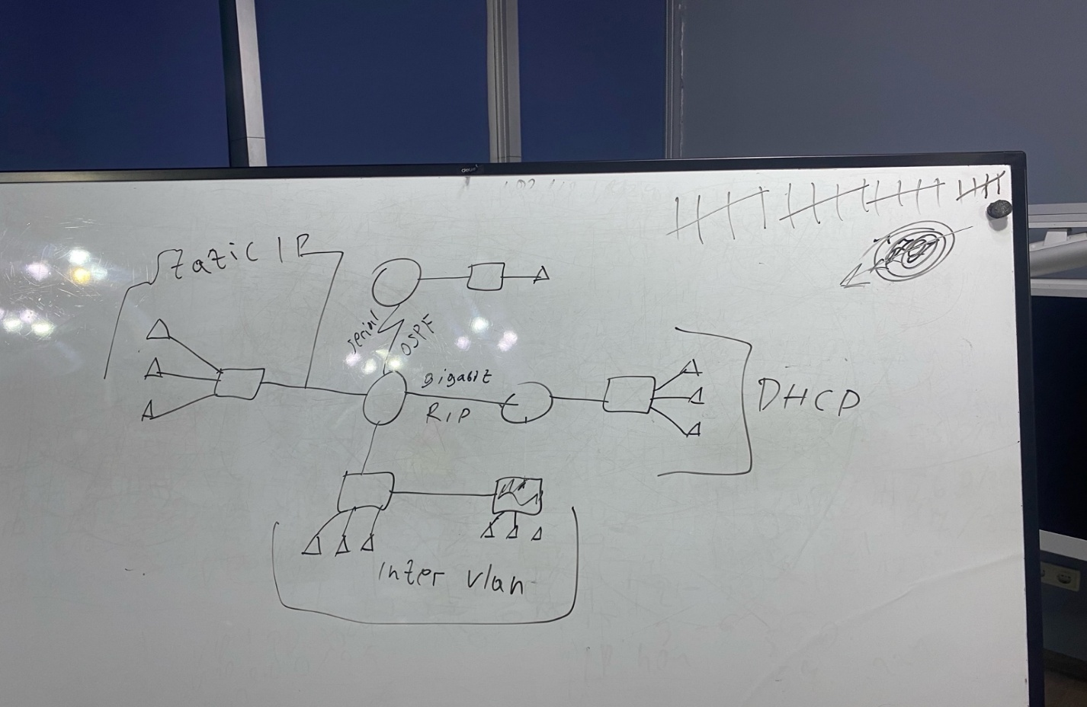
ზუსტი ინსტრუქცია:
STEP 1 — Router0 (CENTER) interfaces (IP + serial):
enable
conf t

interface g0/2
ip address 10.10.10.1 255.255.255.224
no shutdown
exit

interface g0/0
ip address 12.1.0.1 255.255.255.252
no shutdown
exit

interface s0/3/0
ip address 12.2.0.2 255.255.255.252
no shutdown
exit

interface g0/1
no shutdown
exit

interface g0/1.20
encapsulation dot1Q 20
ip address 10.10.20.1 255.255.255.0
exit

interface g0/1.30
encapsulation dot1Q 30
ip address 10.10.30.1 255.255.255.0
exit

end
wr

STEP 2 — Router2 (TOP) interfaces + OSPF:
enable
conf t

interface g0/0
ip address 10.10.40.1 255.255.255.0
no shutdown
exit

interface s0/3/0
ip address 12.2.0.1 255.255.255.252
no shutdown
exit

router ospf 1
network 12.2.0.0 0.0.0.3 area 0
network 10.10.40.0 0.0.0.255 area 0
end

wr

STEP 3 — Router1 (RIGHT) interfaces + DHCP + RIP:
enable
conf t

interface g0/0
ip address 12.1.0.2 255.255.255.252
no shutdown
exit

interface g0/1
ip address 12.4.0.1 255.255.255.0
no shutdown
exit

ip dhcp excluded-address 12.4.0.1 12.4.0.20
ip dhcp pool DHCP_RIGHT
network 12.4.0.0 255.255.255.0
default-router 12.4.0.1
dns-server 8.8.8.8
exit

router rip
version 2
no auto-summary
network 12.1.0.0
network 12.4.0.0
passive-interface g0/1
end

wr

STEP 4 — Switch2 + Switch3 VLAN + trunk (Inter-VLAN part):
Switch2 (BOTTOM LEFT):
enable
conf t

vlan 20
vlan 30
exit

interface fa0/1
switchport mode trunk
switchport trunk allowed vlan 20,30
exit

interface fa0/2
switchport mode trunk
switchport trunk allowed vlan 20,30
exit

interface range fa0/3 - 5
switchport mode access
switchport access vlan 20
spanning-tree portfast
exit

end
wr

Switch3 (BOTTOM RIGHT):
enable
conf t

vlan 20
vlan 30
exit

interface fa0/4
switchport mode trunk
switchport trunk allowed vlan 20,30
exit

interface range fa0/1 - 3
switchport mode access
switchport access vlan 30
spanning-tree portfast
exit

end
wr

STEP 5 — Router0: Routing (OSPF + RIP + redistribution):
enable
conf t

router ospf 1
passive-interface default
no passive-interface s0/3/0
network 12.2.0.0 0.0.0.3 area 0
network 10.10.10.0 0.0.0.31 area 0
network 10.10.20.0 0.0.0.255 area 0
network 10.10.30.0 0.0.0.255 area 0
redistribute rip subnets
exit

router rip
version 2
no auto-summary
passive-interface default
no passive-interface g0/0
network 12.1.0.0
network 10.10.10.0
network 10.10.20.0
network 10.10.30.0
redistribute ospf 1 metric 2
exit

end
wr

STEP 6 — PC IP settings (exactly what to type)
Left Static LAN (Switch4) — 10.10.10.0/27
Gateway: 10.10.10.1
Mask: 255.255.255.224
- PC10: 10.10.10.10
- PC11: 10.10.10.11
- PC12: 10.10.10.12
(Desktop → IP Configuration → Static)

Top LAN (PC0) — 10.10.40.0/24
Gateway: 10.10.40.1
Mask: 255.255.255.0
- PC0: 10.10.40.10

Bottom VLAN20 (Switch2 PCs) — 10.10.20.0/24
Gateway: 10.10.20.1
Mask: 255.255.255.0
- PC7: 10.10.20.10
- PC8: 10.10.20.11
- PC9: 10.10.20.12

Bottom VLAN30 (Switch3 PCs) — 10.10.30.0/24
Gateway: 10.10.30.1
Mask: 255.255.255.0
- PC4: 10.10.30.10
- PC5: 10.10.30.11
- PC6: 10.10.30.12

Right DHCP LAN (Switch1 PCs) — DHCP
- PC1 / PC2 / PC3 → Desktop → IP Configuration → click DHCP
They should get 12.4.0.x automatically.

STEP 7 — Tests (must work if everything is correct)
A) Inter-VLAN test
From PC7:
ping 10.10.30.10
From PC4:
ping 10.10.20.10
ყველაფერი იმუშავებს ამის შემდეგ და ეგ არის.

